Ottawa Gardens Pre School

Child Protection Policy

Purpose

To ensure all possible actions are taken to protect children from abuse and neglect.

Relevant Background (including legislation/regulation references)
Licensing Criteria 2008, Health and Safety, Child Protection documentation required:
- HS31: A process for the prevention of child abuse and a procedure for responding to suspected child abuse. Documents are consistent with Child, Youth and Family or New Zealand Police guidelines.
- HS32: all practicable steps are taken to protect children from exposure to inappropriate material (for example, of an explicitly sexual or violent nature).
- Reg56: Ill-Treatment of children
- Reg57: Health and Safety of Children
- Reg58: Collection of children from centres and home-based education and care services
Vulnerable Children’s’ Act 2014.
See Ministry of Education child abuse information on: http://www.lead.ece.govt.nz

Position Statements

Ottawa Garden’s Preschool and all employees are committed to the prevention of child abuse and neglect and to the protection of all children.

Failure to protect children will not only lead to lifelong damage for children, it will also seriously damage the reputation of the centre, its staff and the reputation of early childhood centres.
The safety and wellbeing of the child will always be given priority when investigating suspected or alleged abuse.

We support the roles of the Police and Child, Youth and Family in the investigation of suspected abuse and will report suspected/alleged abuse to these agencies.
We support families to protect their children.

Information, discussion, trusting relationships and clear procedures will strengthen the ability of staff, parents and children to work together to adequately protect all the children who attend the centre.
We provide a safe environment, free from physical, emotional, verbal or sexual abuse.

Creating a safe organisation requires an understanding of the many ways in which children can be at risk of abuse, and creating clear and decisive actions that an organisation can take to minimise the potential risk and respond appropriately should abuse occur.
This policy will be reviewed annually or more frequently as required.

Issue Outline

The intention of the Vulnerable Child’s Act identifies that everyone within the community take responsibility to report any suspected abuse. All staff must be able to clearly identify the signs and symptoms of abuse, and have the confidence to take the appropriate action.
Child protection matters are to be treated with urgency
Child abuse and neglect is not acceptable. Children need our protection. Where protection is not adequately provided by the adults responsible for the child, others need to step in to ensure the child receives adequate protection.
Definitions
Child Abuse is defined in the Children Young Persons and their Families Act as “the harming (whether physically, emotionally, or sexually), ill-treatment, abuse, neglect or deprivation of any child or young person.”

Physical abuse – any acts that may result in physical harm of a child or young person. It can be, but is not limited to: bruising, cutting, hitting, beating, biting, burning, causing abrasions, strangulation, suffocation, drowning, poisoning and fabricated or induced illness.

Sexual abuse – any acts that involve forcing or enticing a child to take part in sexual activities, whether or not they are aware of what is happening. Sexual abuse can be, but is not limited to:

- Contact abuse: touching breasts, genital/anal fondling, masturbation, oral sex, penetrative or non-penetrative contact with the anus or genitals, encouraging the child to perform such acts on the perpetrator or another, involvement of the child in activities for the purposes of pornography or prostitution.
- Non-contact abuse: exhibitionism, voyeurism, exposure to pornographic or sexual imagery, inappropriate photography or depictions of sexual or suggestive behaviours or comments.
Emotional abuse – any act or omission that results in adverse or impaired psychological, social, intellectual and emotional functioning or development. This can include:

- Patterns of isolation, degradation, constant criticism or negative comparison to others. Isolating, corrupting, exploiting or terrorising a child can also be emotional abuse.
- Exposure to family/whānau or intimate partner violence.

Neglect “is a pattern of behaviour which occurs over a period of time and results in impaired functioning or development of a child. It is the failure to provide for a child’s basic needs.
Neglect may be:
- Physical - failure to provide necessary basic needs of food, shelter or warmth
- Medical - failure to seek, obtain or follow through with medical care for the child
- Abandonment - leaving a child young person in any situation without arranging necessary care for them and with no intention of returning
- Neglectful supervision – failure to provide developmentally appropriate or legally required supervision
- Refusal to assume parental responsibility - unwillingness or inability to provide appropriate care for a child.”
What happens when you report abuse or neglect?

- When the Manager or Centre Owner call Child Youth and Family you will be able to talk directly with trained social workers. They will ask questions to find out what’s going on with the family or children you’re worried about.
- They will then look into the situation to find out what may be happening, whether we need to work with the family, or put them in touch with people in their community that can help.
- It takes a while to assess the problems and find the right solutions, so don’t expect immediate results. You should be contacted by us within the month to let you know how we followed up your call.
- If the social worker thinks the child is in immediate danger, we will make sure we act on your call within 24 hours.

Sourced from CYF website: Keeping Kids Safe - What happens when I call Child, Youth and Family?
http://www.cyf.govt.nz/documents/about-us/publications/keepingkids-safe.pdf

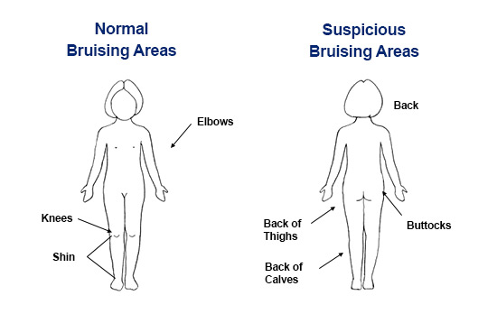From Child Matters website: childmatters.org.nz

Detail
The Centre Manager/or Registered Teacher will:
- Always prioritise the safety and wellbeing of the child.
- Maintain confidentiality. Failure of employees to comply with this policy will be regarded as serious misconduct.
- Respect the rights of those involved during any investigation.
- Maintain and increase staff and parental awareness of how to prevent, recognise and respond to abuse, including learning about appropriate touching.
- Immediately investigate and fully and objectively record in writing, any reports of incidents, allegations or suspicions of child abuse.
- The Manager will, where appropriate, seek the assistance of the Ministry of Education, Child, Youth and Family, Children’s Team (Christchurch), Policy and/or other professional agencies in order for appropriate follow up/investigation/support to be undertaken.
- Report child abuse to the Police or Child, Youth and Family.
- Inform parents after discussing the best way to do this with Police or CYFS advisors. If a family member of close associate of the family or whanāu is suspected of child abuse, the parent(s) may not initially be informed, but the centre will ensure that the information is disclosed by an appropriate person at an appropriate time.
- Suspend a staff member under suspicion until a full investigation can be completed.
- Carry out police vetting checks in accordance with the Vulnerable Children’s Act 2014.
- Ensure that permanently employed staff over the age of 17 years are responsible for any tasks that involve nappy changing, toileting or any situation requiring sole responsibility for the supervision of children.
- Ensure that staff and other adults visiting or working in the centre are well supported and visible in the activities they perform with children. While the centre respects the privacy of our children, staff and visitors, visibility will be given priority to ensure the safety of all concerned.
- Respond appropriately to a child who initiates physical contact in seeking affection, reassurance or comfort. It is not appropriate to force any form of unwanted affection/touching on a child. Touching should not be initiated to gratify adult needs. Physical contact during the changing or cleansing of children must be for the purpose of that task only and not be more than is necessary for the job.
- Ensure no child is taken from the centre by any staff member or adult, without the permission of a parent, except in the case of an emergency where clearance has been obtained from the Centre Manager.
- Maintain appropriate records.
- Ensure the centre’s procedures protect staff from unjustified allegations of abuse.
- Ensure the centre has resources for children and adults on child abuse.
Employees of Ottawa Garden’s Preschool. will:
- Always prioritise the safety and wellbeing of the child.
- Familiarise themselves with this centre policy.
- Immediately notify the Centre Manager if they observe signs of child abuse or anyone reports to them any suspicions of child abuse of children at the centre, or a pattern of neglect or concerns is identified. Staff will not act in a way that is outside their knowledge or capacity
- The manager will consult with Child, Youth and Family to clarify whether a notification of concern should take place.
- If it is decided that concerns do not require a notification to statutory authorities, the child will continue to be monitored, and records kept.
- Maintain confidentiality. Failure of any employee to comply with this policy will be regarded as serious misconduct.
- Staff will not question extensively a child who has disclosed abuse, or who is displaying signs of possible abuse. However, it is important that a child is listened to and responded to appropriately
- Respond appropriately to a child who initiates physical contact in seeking affection, reassurance or comfort. It is not appropriate to force any form of unwanted affection/touching on a child. Touching should not be initiated to gratify adult needs. Physical contact during the changing or cleansing of children must be for the purpose of that task only and not be more than is necessary for the job.
- In all cases of suspected abuse, the information and concerns will be made available only to those staff who have a need to know. This will be determined by the Centre Manager.
- All staff members involved will be kept informed as far as possible within the limits of confidentiality and the need to protect the best interest of the child. This will be determined by the Centre Manager
- Never take a child from the centre without the permission of a parent, except in the case of an emergency where clearance has been obtained from either the Centre Manager or owner.
- Staff members are responsible for ensuring they follow the requirements and practises of all Ottawa Garden’s Preschool policies and procedures. This practise in itself will provide a high level of protection for staff from allegations of child abuse.
Copyright Child Matters 2014 19 www.childmatters.org.nz

Action re breach of Court Orders (ie Restricted Access)

A Court order will usually be accompanied by a safety plan and agreements from any family group conferences. All documents will be supplied by a CYPs representative.

If a person named on the Court order attempts to remove or have access to the child the manager is to call the Police immediately, quote the court order number and any other relevant detail eg car registration number, persons description, details of others involved etc. They are then to contact the child’s noted caregiver and tell them of events. AT THE SAME TIME the manager or senior staff member is to try to prevent the child being removed. They are also to attempt to prevent the situation from escalating and to be aware of the safety of the other children at the centre.

The only time access can be denied to a birth parent is if there is a COURT ORDER issued by the Court and Ottawa Garden’s Preschool has a copy on the child’s file. Court orders are legal documents and are enforceable by the Police

People Uplifting Children Who Have No Authority to Do So

The authority here is the Legislation governing the operation of an ECE Centre and the criteria that only those persons authorised by a parent ie detailed on the enrolment form or added later, are able to take possession of the child and remove them from the premies.

Advise the person concerned that you have not been authorised to release the child into their care and you need the authority of their parent. Ring the parent/guardian and advise who the person is who has come to pick up the child; ask if they should be added to the persons authorised list.

If you are not able to contact any caregivers you have the option of the child remaining in the centre until you do contact them or taking the child home in staff vehicle (if there is an authorised person at home)

Protected Disclosure
- When an employee or associate brings a case of child abuse to the attention of the center or the authorities, Ottawa Garden’s Preschool will not disclose the name of the person without their permission unless it is to CYF or the Police and is considered imperative to do so in the interests of the child.
Safer Recruitment

From 1 July 2015 the Vulnerable Children Act 2014 (external link) prohibits people with child abuse, sexual offending or violence convictions from working in core worker roles. One year after this (i.e. 1 July 2016), this prohibition will be extended to workers in already employed or engaged in core workforce roles.

This means that anyone convicted of the offences listed in the Act won’t be able to work in core children’s roles unless they are granted an exemption before the dates above (i.e. 1 July 2015 for workers seeking to start work, and 1 July 2016 for workers already employed or engaged).

All Ottawa Garden’s Preschool, must also have a current Police clearance that is reviewed every 3 years.

- As employers Ottawa Garden’s Preschool will ensure that an employee applicant’s work history will be thoroughly checked and a police vet completed.
- Ottawa Garden’s Preschool will ensure that they are up to date with the current vetting legislation under the Vulnerable Children’s Act (2014). The current requirements are that all staff complete and pass a clean slate vetting check (June 2015).

Alignment with Other Policies
- Human Resource policies – police vets and careful employment of temporary staff, casual staff, volunteers.
- Outings and excursions policy
- Complaints policy.

Child Protection Procedures
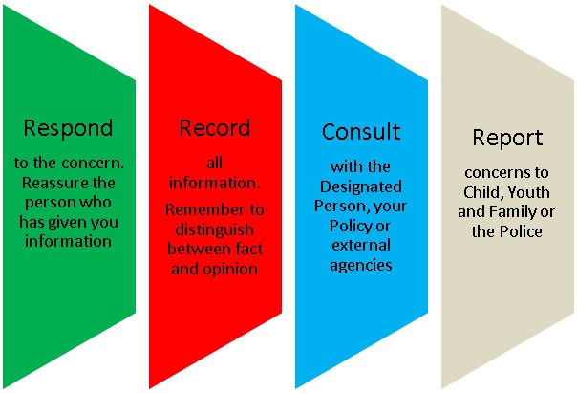

Date Adopted_______________________Date for Review____________________________
Signed____________________________

